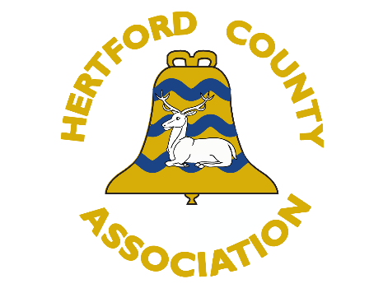
Hertford County Association of Change Ringers
HCACR are running a series of weekend workshops in October 2023 for our members. We are offering Plain Hunt, Plain Bob Doubles and combined Plain Bob Minor / Treble Bob Hunting (this course is yet to be confirmed). Please get guidance about the most appropriate workshop for your level by discussing your application with your tower captain or trainer.
The total cost for the weekend will be £20 which will be due when your place is confirmed. Please submit your completed application form to the Training Officer (trainingofficerbshcacr@gmail). The closing date for applications is 31 AUGUST.
Full name
Email address
Telephone number
Date of Application
If you will be under 18 on the first day of the course, please give your age
Of which District are you a member?  Bishop’s Stortford  Eastern  Northern | St Albans  Watford  Western
Course you are applying for | Plain Hunt on 5 (7-8 Oct)  Plain Bob Doubles (21-22 Oct)  Bob Minor / Treble Bob Hunt (14-15 Oct)
Please confirm - The information sheets can be found at http://www.hcacr.org.uk/training.php | I have read the relevant information sheet including the pre-requisite skills
Where will you be able to practise your new skills after the workshop?
Name and email of tower captain / trainer
Any additional needs we need to be aware of?

